
DEPARTMENT OF TELECOMMUNICATION ENGINEERING
Control Systems

- A signal flow graph is the graphical representation of the relationships between the variables of set linear algebraic equations.
a) True
b) False
Answer: a
Explanation: By definition signal flow graphs are the graphical representation of the relationships between the variables of set linear algebraic equations.

- A node having only outgoing branches.
a) Input node
b) Output node
c) Incoming node
d) Outgoing node
Answer: a
Explanation: Nodes are the point by which the branches are outgoing or ingoing and this can be input or output node and input node is the node having only outgoing branches.

- Use mason’s gain formula to find the transfer function of the given signal flow graph:
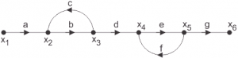
a) abd/1-(ac)
b) abdeg/1-(bc+ef)+bcef
c) abd/1-(bc+ef)+bcef
d) adcdef/1-(bc+ef)+bcef
Answer: b
Explanation: Using mason’s gain formula transfer function from signal flow graph can be calculated which relates the forward path gain to the various paths and loops.
- Use mason’s gain formula to find the transfer function of the following signal flow graph:
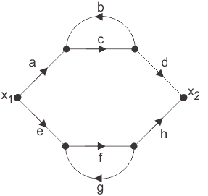
a) abcd+efg/1-cd-fg-cdfg
b) acdfg+bcefg/1-cd-fg-cdfg
c) abef+bcd/1-cd-fg-cdfg
d) adcdefg/1-cd-fg-cdfg
Answer: b
Explanation: Using mason’s gain formula transfer function from signal flow graph can be calculated which relates the forward path gain to the various paths and loops.

- Loop which do not possess any common node are said to be ___________ loops.
a) Forward gain
b) Touching loops
c) Non touching loops
d) Feedback gain
Answer: c
Explanation: Loop is the part of the network in which the branch starts from the node and comes back to the same node and non touching loop must not have any node in common.

- The mechanism of control of body temperature is non feedback system?
a) True
b) False
Answer: b
Explanation: It is feedback system as the temperature of our body is regulated periodically and being warm blooded we regulate our body temperature w.r.t. to the climate.

- Benefits of feedback:
a) Performance of system is greater.
b) Need for system much larger path gain and system instability.
c) Controlled variable accurately follows the desired value
d) Affected by parameter variations
Answer: d
Explanation: Closed loop system is the system with the feedback and this can be positive or negative feedback and having feedback have less dependence on parameter variation.

- Feedback always increases the gain?
a) True
b) False
Answer: b
Explanation: It cannot always increase gain it can also reduce the gain as gain of Open loop control system is more as compared to it.

- Effect of feedback on sensitivity is minimum in:
a) Open loop control system
b) Closed loop control system
c) None of the mentioned
d) Both of the mentioned
Answer: b
Explanation: Sensitivity is defined as the change in output with respect to change in parameter or input and for a good control system the sensitivity must be less and in closed loop control system it gets reduced by the factor of 1/(1+GH).

- Feedback control systems are:
a) Insensitive to both forward and feedback path parameter changes
b) Less sensitive to feedback path parameter changes than to forward path parameter changes
c) Less sensitive to forward path parameter changes that to feedback path parameter changes
d) Equally sensitive to forward feedback path parameter changes
Answer: c
Explanation: Feedback control system can be positive and negative but positive feedback systems less widely used as the positive feedback systems are more sensitive to parameter variations but negative feedback are less sensitive to change in G than change in H.

- Consider the following statements with respect to the feedback of the control systems:
1. In general the sensitivity of the system gain of a feedback system of a parameter variation depends on where the parameter is located.
a) 1,2 and 3 only
b) 1,3 and 4 only
c) 1,2 and 4 only
d) 1,2,3 and 4 only

Answer: b
Explanation: Negative feedback increases stability but not positive positive feedback reduces the stability and for this reason negative feedback systems are used .

- The closed system has higher ________ than open loop control system, this implies increased speed of response.
a) Gain
b) Bandwidth
c) Frequency
d) Speed
Answer: b
Explanation: As transient response of the system is improved by the use of feedback and it causes the settling time to reduce and closed loop system has higher bandwidth than open loop systems and this implies increase in speed of response.

- First order system is defined as :
a) Number of poles at origin
b) Order of the differential equation
c) Total number of poles of equation
d) Total number of poles and order of equation
Answer: d
Explanation: First order system is defined by total number of poles and also which is same as the order of differential equation.

- A unit step is applied at t=0 to a first order system without time delay. The response has the value of 1.264 units at t=10 mins, and 2 units at steady state. The transfer function of the system is_____________
a) 3/(1+600s)
b) 2/(1+500s)
c) 5/(1+220s)
d) 2/(1+600s)
Answer: d
Explanation: a(t)= k[1-e^-t/T] K=2
0.632= 1-e^-10/T
T=600 sec
G(s)=2/(1+600s).
- The transfer function of the system is G(s) =100/(s+1) (s+100). For a unit step input to the system the approximate settling time for 2% criterion is:
a) 100 sec
b) 4 sec
c) 1 sec
d) 0.01 sec
Answer: b
Explanation: G(s) =100/(s+1) (s+100)
Taking the dominant pole consideration,
S=-100 pole is not taken.
G(s)= 100/s+1
Now it is first order system, ts=4T=4 sec.
- If a first order system and its time response to a unit step are as shown below, the gain K is :
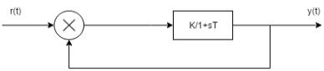
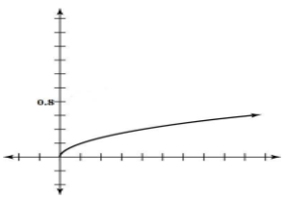
a) 0.25
b) 0.8
c) 1
d) 4
Answer: d
Explanation: Y(s)/R(s)=K/1+sT+K
By, use of partial fraction, K/T/s+(K+1/T)
Taking inverse Laplace transform on both the sides
Y(t)=K/K+1[1-e^(K+1/T)t] K=4

